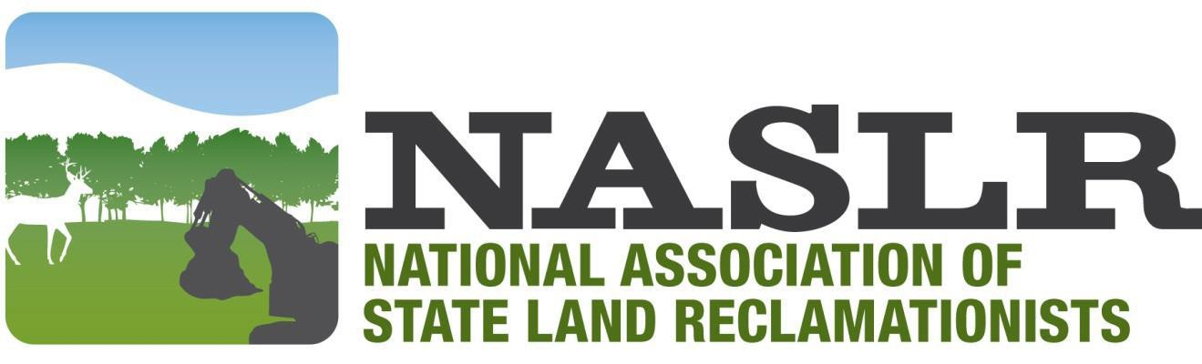

Outreach Award
Objective: To recognize an individual (or work group) who is a positive model for the mining industry.

Criteria:
- Displays a cooperative attitude.
- Provides educational outreach programs.
- Assumes industry leadership.
- Participates in their community.
- Goes beyond the minimum to achieve excellence.
- Takes innovative approaches to operational and reclamation challenges.
- Practices environmental stewardship of the land and water.
- Maintains a visually appealing operation. (If applicable)
- Possesses no pattern of violations. (If applicable)

Description:
Many individuals do things to promote a positive image for the mining industry. The NASLR Outreach Award recognizes these efforts. The nominee is involved in community outreach projects for the mining industry. These could be classroom visits, or community and youth group presentations. They share their leadership skills with associations, committees, and civic groups. The nominee may have been involved with activities which dealt with minimizing the visual or negative impact the mining operation could have on the surrounding area. Individuals nominated need not be company owners. The judges will be looking for people who make a difference whenever they can. The nominee has a history of cooperation with the regulatory authority in all areas. (If responsibilities apply) There is a well maintained and cared for look during all phases of the operation and areas are tidy. Equipment is well maintained. Entrances are visually attractive.
The site does not have a history of violations.

Award:
The NASLR Outreach Award will be a plaque presented to the winner at the annual conference. Fees will be waived for the winner and one guest.

Directions:
Applications should include the attached cover sheet and an essay, not to exceed five single spaced pages detailing how the nominee meets the above criteria. Up to three pages of supplemental materials should be included for documentation. Applications must be received by July 1 of each year to be considered for that year’s award. Please submit the application via email(s) of 5MB or less to the contact listed on the web page.

NASLR Outreach Award
Date: Name: Company: Address: City, State, Zip Code: Phone: Fax: Email:

Nominated by: Signature: Title: Phone: Agency: Address: City, State, Zip Code: Email:

